Postgraduate Student Internship Awards

The Australian Plant Phenomics Facility is enthusiastic about highly motivated and research focused postgraduate students joining its team as interns. To help attract the very best students, we provide postgraduate internship grants.
This is your chance to investigate your plant science questions with the support of the highly skilled APPF team and the incredible technology and infrastructure we have available.
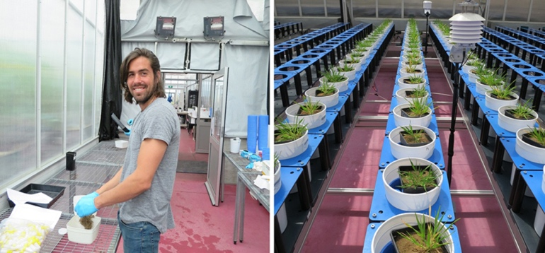
Background
The Australian Plant Phenomics Facility (APPF) is a world leading research facility aimed at underpinning innovative plant phenomics studies to accelerate the development of new and improved crops, healthier food and more sustainable agricultural practice.
Established under the National Collaborative Research Infrastructure Strategy (NCRIS), the APPF involves three highly complementary research facilities in Adelaide (University of Adelaide) and Canberra (CSIRO and Australian National University).
The APPF provides researchers with access to high quality plant growth facilities and state-of-the-art automated phenotyping capabilities in controlled environments and in the field.
To help accelerate research outputs, our phenomics technologies are supported by experts from a number of fields, i.e. agriculture, plant physiology, biotechnology, genetics, horticulture, image and data analysis, mechatronic engineering, computer science, software engineering, mathematics and statistics.
Conditions of Award
APPF postgraduate internship grants involve access to the facility’s phenotyping capabilities to undertake collaborative projects and to work as an intern with the APPF team to learn about experimental design, image and data analysis in plant phenomics.
Selection is based on merit. Applications are assessed on the basis of academic record, research experience, suitability of the research project for APPF infrastructure, collaborative nature of the project and alignment with the APPF vision. Interviews may be conducted.
Interstate students are strongly encouraged to apply! Internship awards may include travel support.
Duration: | The duration of the internship will depend on the nature of the project and phenomics infrastructure use.
Time: | Project timing will depend on availability of the required phenotyping platform.
Award: | The level of support depends on the nature of the project and type and duration of infrastructure use. In general, the award is comprised of a  - maximum of $1,500 towards accommodation in Adelaide or Canberra (if required),  - maximum of $500 towards travel / airfare (if required), and  - a maximum of $10,000 toward infrastructure use.  - Applicants should seek co-contributions to support the project.
Project: | The APPF has identified a number of priority research areas, each reflecting a global challenge and the role that advances in plant biology can play in providing a solution:  - Tolerance to abiotic stress  - Improving resource use efficiency in plants  - Statistics and biometry  - Application of mechatronic engineering to plant phenotyping  - Application of image analysis techniques to understanding plant form and function.  Students proposing other topics will also be considered.  A project plan will be developed between the student, their supervisor/s and the APPF team.
Eligibility: | We are looking for enthusiastic postgraduate students with a real interest in our research and technology who are self-motivated and able to work under limited supervision. Current postgraduate students in the following areas are encouraged to apply:
 | - Agriculture | - Biology | - Bioinformatics
 | - Biotechnology | - Computer Science | - Genetics
 | - Mathematics | - Plant Physiology | - Science
 | - Software Engineering | - Statistics
Conditions: | - Applicants should seek co-contributions to support their project.  - Successful applicants must be willing to publish all aspects of the experiment, not just the components carried out at the APPF, on an online digital repository such as Figshare.  - Successful applicants must submit a report within six months of completion of the plant imaging phase, describing the project, how the facility helped address their research question, preliminary research findings and anticipated and/or achieved results.  Please note COVID 19 restrictions must be observed, including for travel. Please contact APPF staff to discuss arrangements prior to submitting your application.
Note: | The APPF reserves the right not to make an award.
Deadline: | There are two rounds of applications during the year. Submission deadlines:  - 31 May  - 30 November  Applications may be considered outside of these deadlines at the discretion of the APPF Executive Committee. Please discuss this with one of the APPF staff listed below.
Applications: | Postgraduate students are required to contact APPF staff prior to submitting their application to discuss possible projects and costing of projects.  - APPF @ CSIRO, Canberra: Dr Rob Coe  - APPF @ ANU, Canberra: Dr Richard Poire or Dr Tim Brown  - The Plant Accelerator, Adelaide: A/Prof Bettina Berger or Dr Ken Clarke  The applicant’s CV and a letter of support from their PhD supervisor must be attached to the application.  Applications must be submitted using the attached application form below to helli.meinecke@adelaide.edu.au

Postgraduate Student Internship Award Application
About the Applicant
Family Name: |  |  |  | Given Name:
Email address: |  |  |  | Phone No.:
Organisation:
Department:
Street address:
Suburb: |  |  |  | P/C and State:
PhD Supervisor/s:
Supervisor’s email:
PhD Scholarship Award:
Proposed Project
Project Title:

Research question to be addressed:

Plant species to be studied and country of origin of seed material:

APPF infrastructure involved:

Description of the project (~ 250 words):

Relevance of proposed phenomics experiment to the applicant’s PhD project:

Please comment on your research group’s and/or organisation’s ability to provide statistical analysis support of the large datasets acquired from using APPF infrastructure.

Which APPF staff member has been consulted on project feasibility, design and costing?

Budget: Please advise of the total project costing and indicate how much support is sought from the APPF and how much support you will receive from your host institution (*refer to APPF maximum contributions below):
Description |  | Total Budget | APPF contribution |  | Applicant’s co-contribution/s
Infrastructure access (including consumables and other services provided by APPF)
Accommodation
Travel
Other
TOTAL

*The APPF provides a maximum contribution of
$10,000 toward infrastructure use,
$1,500 towards accommodation in Adelaide or Canberra (if required), and
$500 towards travel / airfare (if required).

I have attached my CV.
I have attached a letter of support from my PhD supervisor.
I agree to publish all aspects of my research on Figshare (or other platform).

