An Invitation to Barley Researchers in Australia

Field Trial Access Invitation – OzBarley field trials in 2024 in WA, SA and NSW

Invitation
The GRDC and the OzBarley project team, led by the Australian Plant Phenomics Facility and University of Adelaide, invite expressions of interest from barley researchers wishing to access field trials of the OzBarley elite panel in WA, SA and/or NSW in 2024.
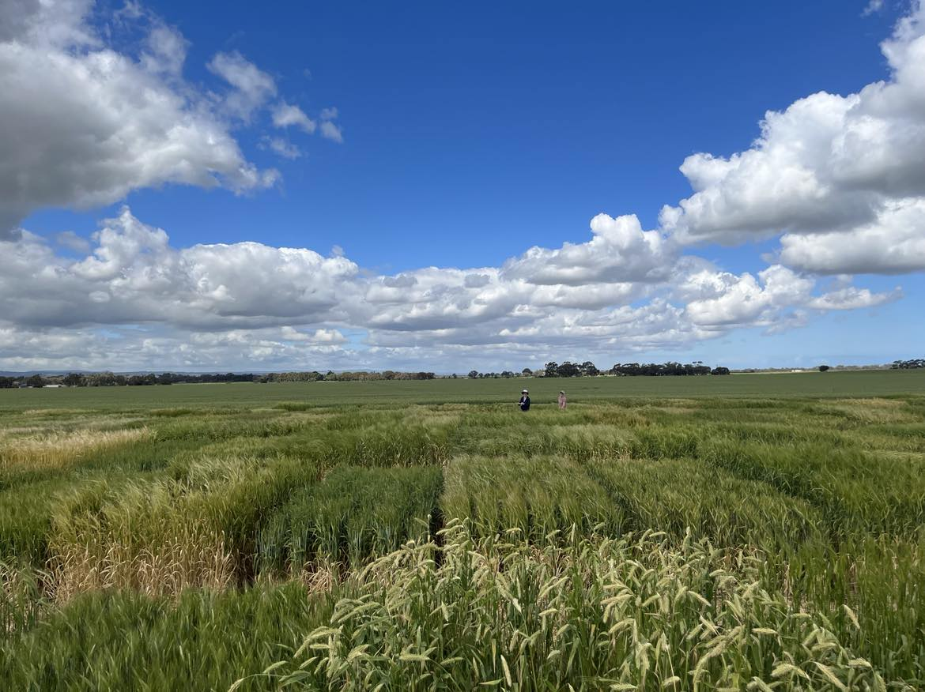

Background
OzBarley is a national data asset, funded by the Australian Research Data Commons and the GRDC, with co-contributions from many research and industry partners. The OzBarley data platform is set to launch late 2024 and will provide the basis for in silico research and gene discovery. OzBarley will reduce the barrier to entry for barley pre-breeding research, since the generation and genotyping of barley populations and panels (a large financial and time commitment), is already provided and scientists can focus on studying their trait(s) of interest.
At its core, OzBarley comprises a collection of ~220 elite barley varieties, assembled to represent the breeding history of barley in Australia. Pedigree and genotypic data for these lines, including SNP chip and RNAseq SNP data, will be made publicly available to fast-track gene discovery. The vision is for researchers to use the OzBarley resources to accelerate their research interests, while simultaneously growing the OzBarley asset by contributing additional data sets following FAIR data principals. The accumulation of more diverse datatypes will enable future multi-modal data integration to better query complex traits in new ways in an economically important crop.
Supporting the launch of the OzBarley platform in 2024, the elite OzBarley panel will be grown in three locations, York in WA, Roseworthy in SA, and Wagga Wagga in NSW. We invite researchers from across Australia to access these barley trials to phenotype their trait of interest.
Researchers collecting the information are expected to share their data under FAIR principles (Findable, Accessible, Interoperable, Reusable) after a 9-months quarantine period. The quarantine period provides the principal researcher first mover advantage on analysis and publication, while ensuring eventual integration of data into the OzBarley asset for reuse in future industry-focused projects aimed at linking traits to genes for barely improvement.
Researchers can access either a single trial or multiple trials. The phenotypic measurements must not compromise the trial for other users through destructive sampling (e.g. biomass cuts), and should ensure the integrity of the trial plots can be maintained. At each site, lines will be grown in triplicate plots with a locally suitable check variety at higher replication.
Early and mid-career researchers can apply for travel support from GRDC to support their access of the trials.

Project Examples
Opportunities to access the OzBarley trials could include:
- Phenology assessment with repeated visual scoring
- Development of novel UAV-based phenotyping approaches to e.g. measure crop canopy, architecture or head numbers
- Post-harvest assessment of grain quality traits from grain samples
- Measurement of photosynthetic or water use efficiency parameters using e.g. gas-exchange, Hyperspectral Leaf Reflectance, or natural 13C abundance (δ13C) in leaves and grain (i.e. carbon allocation properties).

Eligibility
- All barley researchers in Australia are eligible to apply for access
- Early and mid-career researchers (10-year post PhD equivalent) are eligible to apply for travel support of up to $2,000 AUD

Conditions of Access
- Applications by EMCRs for travel support must be submitted by 22 December 2023 using the attached form.
- Applications to access the trials (without the need for travel support) must be submitted by 31 March 2024 using the attached form.
- All in-field measurements must be collected in the 2024 growing season.
- Participants of the scheme must adhere to the safety protocols of the local trial operator.
- Successful applicants are expected to attend a brief training session on FAIR data principles and the OzBarley platform in 2024 prior to the trial beginning.
- Whilst the successful applicants will be the custodians of the data, it is expected that data will be shared (CC-BY-4.0 license preferred) after a 9-months quarantine period to allow for analysis and manuscript preparation.

Guidelines
- Assessment: Applications for travel support will be assessed based on scientific merit and their potential to contribute to the OzBarley data asset.
- Pricing: Access to the OzBarley field trials is free of charge. Researchers will need to cover the cost of phenotyping their trait of interest.

Questions
For further questions please contact bettina.berger@adelaide.edu.au

Applications / Expressions of Interest
Deadline: 22 December 2023 if requesting travel support; 31 March 2024 if no travel support required
Expressions of interest must be submitted using the attached form by email to bettina.berger@adelaide.edu.au

2024 OzBarley field trial access
Expression of Interest
1. Applicant Details
Family Name: |  |  |  |  |  |  |  | Given Name:
Title: |  |  |  | Email address:
Phone: |  |  |  |  |  | Mobile or Home:
Organisation:
Department:
Postal Address:
PO Box or Street / Suburb / State / Post Code
EMCR applying for travel support |  |  |  |  | YES/NO
2. Project Overview, hypothesis and phenotypic data to be collected (100 words or less)
3. Please explain how the collected data will benefit your research project and the value of the data to the broader Australian barley research community (200 words or less)
4. Other project information
Trials to be accessed: |  |  |  |  |  |  | ☐WA (York)  ☐ SA (Roseworthy)  ☐ NSW (Wagga Wagga) |  |  |  | # of visits:  # of visits:  # of visits:
Approximate time points for access (e.g. once at grain fill; weekly after anthesis):
Is there any potential impact of your measurement on the trial (e.g. leaf sampling, soil sampling): |  |  |  |  |  |  | NO/YES – please specify
Travel support requested: |  |  |  |  |  |  | Please provide a brief budget detailing costs for travel/accommodation per visit
Please return this form and a 2-page CV by 22 December 2023 by email to bettina.berger@adelaide.edu.au if you wish to be considered for travel support.
If you do not require travel support, please return by 31 March 2024.

