An Invitation to Australian Plant Scientists

Pilot Project Invitation - New Precision Agriculture UAV Platform
Unmanned Research Aircraft Facility (URAF)
in partnership with The Plant Accelerator®, University of Adelaide

URAF invites expressions of interest from Australian plant scientists wishing to undertake projects with the URAF Precision Agriculture Unit at The University of Adelaide.

Background
The Unmanned Research Aircraft Facility at the University of Adelaide was established in 2015 to facilitate the use of Remotely Piloted Aircraft Systems for environmental applications in South Australia.
In 2016, URAF has partnered with The Plant Accelerator® to provide improved phenotyping capabilities to support plant and agricultural science.
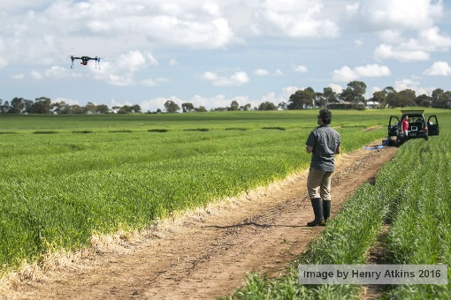
URAF researchers use sensors on board remotely piloted aircraft to monitor plant growth and vigour for agricultural and ecological research. Platforms range from multi-copters to fixed wing aircraft, carrying cameras and multispectral and thermal sensors. Imagery captured produce GIS layers used to integrate with field data to further develop relationships between plant growth, environmental conditions and plant treatment. The potential to measure parameters on field trials such as establishment, height, biomass, stress and nutritional status can be explored using this technology.

Project Examples
The opportunity exists to use the URAF Precision Agriculture Unit for projects monitoring field trials during the 2017 growing season. Projects could include:
- Undertaking studies to support grant applications.
- Undertaking new experiments or developing new protocols to add value to related research.
- Replicating previously completed experiments using the new platform to validate hypotheses.

Eligibility Applications from all Australian plant scientists will be considered, however the field trial to be monitored must be within South Australia.

Conditions of Funding
- Expressions of interest must be submitted using the attached form.
- Pilot projects must commence before 31 September 2017.
- Successful applicants must provide a short project report (using the template provided) within three months of project completion (i.e. the last day of data captured by URAF).
- Whilst the intellectual property will be owned by the client, URAF and The Plant Accelerator® will be entitled to release information about the pilot project output / data (e.g. the report provided by the applicant) on their websites and/or other public domains.
- URAF and The Plant Accelerator® will have a non-exclusive, royalty-free right to use project IP for non-commercial purposes related to research & teaching.

Guidelines
- Assessment: Project applications will be evaluated by the URAF/TPA Partnership Committee based on the scientific quality of the project and the principal investigators.
- Pricing: URAF use for approved projects are subsidised by NCRIS.
- Location: The location of the projects need to be within South Australia due to travel constraints.

Questions
For further questions please contact ramesh.rajasegaran@adelaide.edu.au

Expressions of interest must be submitted using the attached form by email to ramesh.rajasegaran@adelaide.edu.au

2016 URAF Pilot Project Expression of Interest
1. Applicant Details
Family Name: |  |  |  |  |  |  |  |  |  | Given Name:
Title: |  |  |  |  | Email address:
Phone: |  |  |  |  |  |  |  | Mobile or Home:
Organisation:
Department:
Postal Address:
PO Box or Street / Suburb / State / Post Code
2. Project Overview (100 words or less)
3. Please explain how the use of UAVs can contribute to your project (100 words or less)
4. What on ground trial monitoring, complimentary to the UAV measurements, will be carried out?
5. Other project information
Crop: |  |  |  |  |  |  |  |  | Trial location:
Plot size: |  |  |  |  |  |  |  |  |  |  |  |  | No. of plots
Sowing date: |  |  |  |  |  |  |  |  |  |  | Anticipated harvest date:
No. of observation missions: |  |  |  |  |  |  |  |  |  |  | Approx. timing of missions:
Other environmental conditions / requirements / additional information:

Please return this form by 1 May 2016 by email to ramesh.rajasegaran@adelaide.edu.au

Project Report – URAF
Project Title:
Scientist:
Organisation:
Collaborators:
General information about the project design

Aims of the experiment

Key results and outputs

Statement on how data obtained from the URAF measurements provided new insights into your research

